**Visualizing Dataset**

Exploratory Data Aanlysis (EDA) is an important and recommended first step prior to the training of a machine learning model.

Graphical EDA toolbox can be used to visually detect the presence of outliers, the distribution of the data, and the relationships between features.

1. Scatterplot matrix (pairplot function of seaborn lib)

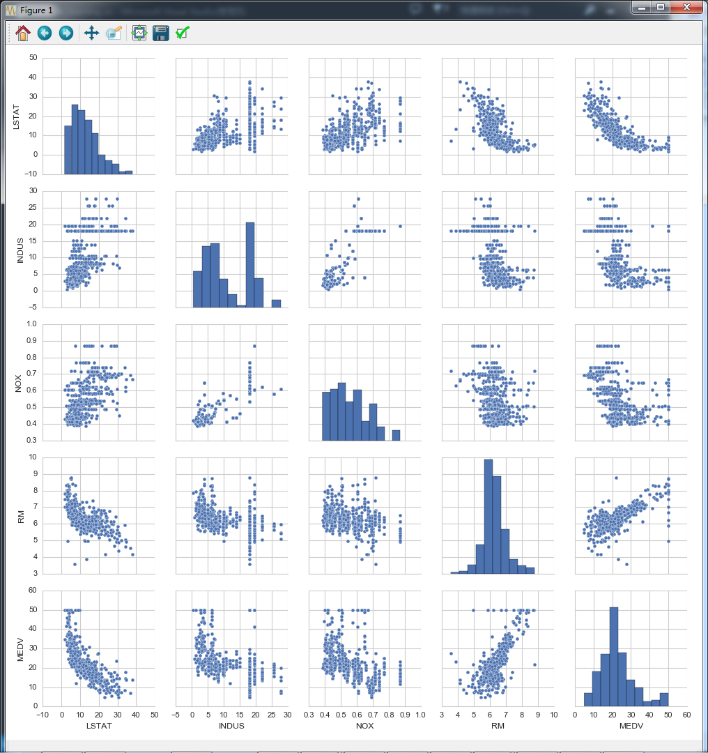

Code: machine-learning/…/linear_regression.py